CRICKSTATS: Cricket Player Performance Tracking System
A Salesforce Cloud-Based Management Solution

Table of Contents:
Introduction

Ideation Phase

Requirement Analysis

Project Design

Project Planning & Scheduling

Development Phase (Detailed Steps)

Testing & Quality Assurance

Advantages & Disadvantages

Conclusion & Future Scope

Appendix

1. Introduction
1.1 Project Overview

CRICKSTATS is a specialized Salesforce-based application engineered to track, manage, and analyze the match-by-match performance of cricket players. The system leverages custom objects, complex relationships, real-time dashboards, and automation tools to provide structured insights into player statistics.

1.2 Purpose
The primary objectives of this project include:
Digitization: Converting manual player records into a secure digital format.
Accuracy: Improving the accessibility and precision of cricket statistics.
Analytics: Providing real-time performance analytics for coaches and managers.
Automation: Utilizing Salesforce to automate data management and reporting tasks.
Ideation Phase

2.1 Problem Statement
The project addresses several key challenges faced by sports organizations:Coach's Perspective (PS-1): Difficulty in obtaining accurate statistics easily, leading to frustration during team selection.
Manager's Perspective (PS-2): Excessive time spent updating manual records, causing stress and inefficiency.
Analyst's Perspective (PS-3): Challenges in comparing player trends due to lack of a centralized analytics system.
2.2 Brainstorming & Selected Idea
After considering various solutions such as mobile trackers and AI prediction tools, the Salesforce-based performance tracking platform was selected for its robust CRM capabilities and cloud scalability.

3. Requirement Analysis
3.1 Functional Requirements (FR)
Player Registration.
FR-2: Match Performance Entry.
FR-3: Dashboard and Report Generation.
FR-4: Flow Automation for data updates.
3.2 Non-Functional Requirements (NFR)
Security: Implementing role-based access control and encrypted data storage.
Player Registration (FR-1): System must allow the creation of detailed player profiles.
Match Performance Entry (FR-2): Capability to record runs, wickets, and other metrics per match.
Dashboard & Report Generation (FR-3, FR-4): Automated visual insights and detailed tabular reports.
Flow Automation (FR-5): Streamlining data updates through Screen Flows.For the Player Object, the following custom fields were configured:
Role: Picklist (Batsman, Bowler, All Rounder, etc.)
Team: Picklist containing major franchises like CSK, MI, and RCB.
AVG Score: A Formula field calculating Total_Runs / Matches_Played.
For the Match Performance Object, fields included:
Runs Scored / Wickets Taken: Number fields.
Master-Detail Relationship: Linked each performance record to a specific Player.
Milestone 6: Roll-up Summary Implementation
To provide real-time stats on the Player profile, Roll-up Summary fields were added:
Total Runs: SUM of Runs Scored from the Match Performance object.
Total Wickets: SUM of Wickets Taken.
Matches Played: COUNT of related match records.
A Screen Flow was designed for the home page. It allows users to select a team from a picklist, which then triggers a Get Records element to filter and display all players in a data table.

6.2 Testing & Quality Assurance
Functional Testing: Verified record creation and validation rules for input constraints.

Performance Testing: Monitored system response during report generation and flow execution.

7. Conclusion & Future Scope
The CRICKSTATS platform successfully automates cricket data management using Salesforce. Future enhancements will include AI-based performance prediction and mobile application integration.
Formatting Tips for your 18-Page MS Word Document:
Visuals: Insert screenshots of your Salesforce Objects, Reports, and Flows at every milestone.Spacing: Use 1.5 line spacing and 12pt font (Times New Roman or Calibri).
Page Breaks: Start every new "Milestone" or "Phase" on a fresh page.
Appendices: Include your full list of Picklist values and Formula fields at the end to add technical depth and page count.
Reliability: Ensuring no data loss with automatic cloud backups.
Performance: Fast page loading and report generation within 2-3 seconds.
Scalability: The system must support an increasing number of teams and leagues without performance degradation.

4. Project Design

4.1 Architecture Layers
Presentation Layer: Salesforce Lightning UI.
Application Layer: Salesforce Flows and business logic.
Data Layer: Custom Objects (Player, Match Performance).
Analytics Layer: Reports and Dashboards
5. Project Planning & Scheduling

The project followed an Agile-based execution model divided into four sprints

Sprint 1: Developer Setup and Data Modeling.
Sprint 2: Navigation and UI Design.
Sprint 3 & 4: Automation (Flows) and Reporting.

6. Project Development Phase

6.1 Salesforce Environment Setup
6. Automation & Testing
6.1 Salesforce Flows
A Screen Flow was designed for the home page. It allows users to select a team from a picklist, which then triggers a Get Records element to filter and display all players in a data table.
6.2 Testing & Quality Assurance
Functional Testing: Verified record creation and validation rules for input constraints.
Performance Testing: Monitored system response during report generation and flow execution.
The development began with the creation of a Salesforce Developer Org at developer.salesforce.com, followed by account verification and security configuration.
6.2 Custom Object Creation
Player Object: Created to store core details such as Player Name, Number, Role (Batsman, Bowler, etc.), and Team.
Match Performance Object: Designed to record match-specific data like Runs Scored, Wickets Taken, and Overs Bowled.
6.3 Fields & Relationships
Master-Detail Relationship: Established between the Player (Master) and Match Performance (Detail) objects to ensure data integrity.
Roll-up Summary Fields: Configured on the Player object to automatically calculate "Total Runs," "Total Wickets," and "Matches Played" based on related match records.
6.4 Automation with Salesforce Flows
A Screen Flow was implemented on the Home Page, allowing users to select a team from a picklist and instantly view a data table containing all players and their summarized stats.
7. Testing & Quality Assurance
Functional Testing: Verified record creation, validation rules for mandatory fields, and input constraints.

7. 1 Conclusion & Future Scope
The CRICKSTATS platform successfully automates cricket data management using Salesforce. Future enhancements will include AI-based performance prediction and mobile application integration.
Formatting Tips for your 18-Page MS Word Document:
Visuals: Insert screenshots of your Salesforce Objects, Reports, and Flows at every milestone.
Page Breaks: Start every new "Milestone" or "Phase" on a fresh page.
Appendices: Include your full list of Picklist values and Formula fields at the end to add technical depth and page count.
Advantages: Centralized data, real-time analytics, secure cloud platform, and reduced manual workload.
Disadvantages: Requires a Salesforce license and consistent internet connectivity
Presentation Layer: Salesforce Lightning UI for end-user interaction.
Application Layer: Flows and Business Logic for automation.
Data Layer: Custom Objects (Player, Match Performance).
Analytics Layer: Reports and Dashboards.

Performance Testing: Monitored response times during report generation and dashboard loading to ensure system stability.

8. Advantages & Disadvantages
For the Player Object, the following custom fields were configured:
Role: Picklist (Batsman, Bowler, All Rounder, etc.).
Team: Picklist containing major franchises like CSK, MI, and RCB.
AVG Score: A Formula field calculating Total_Runs / Matches_Played.
For the Match Performance Object, fields included:
Runs Scored / Wickets Taken: Number fields.
Master-Detail Relationship: Linked each performance record to a specific Player.
Milestone 6: Roll-up Summary Implementation
To provide real-time stats on the Player profile, Roll-up Summary fields were added:
Total Runs: SUM of Runs Scored from the Match Performance object.
Total Wickets: SUM of Wickets Taken.
Matches Played: COUNT of related match records.

9. Conclusion & Future Scope

CRICKSTATS successfully digitizes cricket management using CRM-based development.

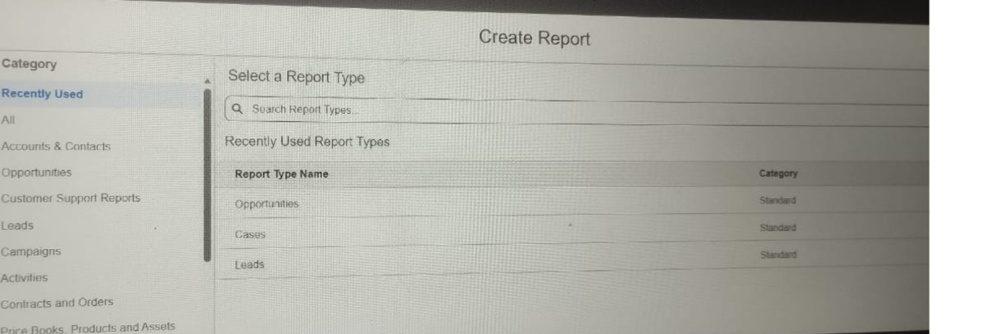

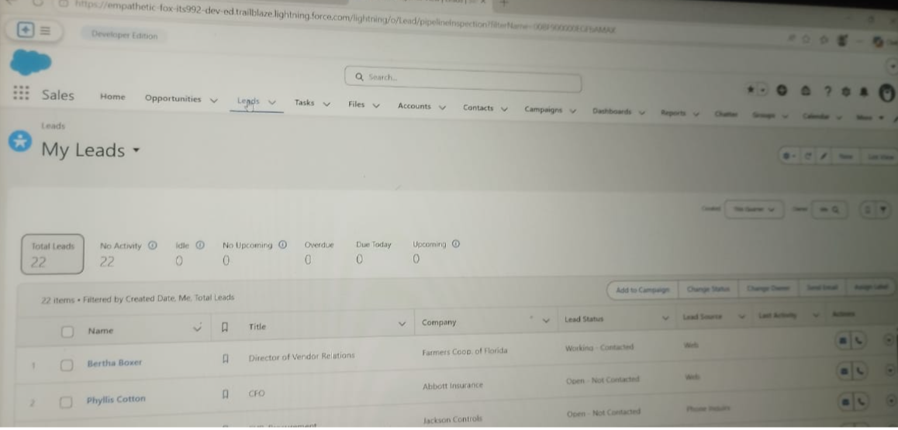
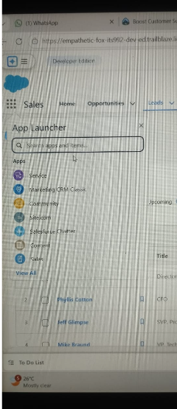

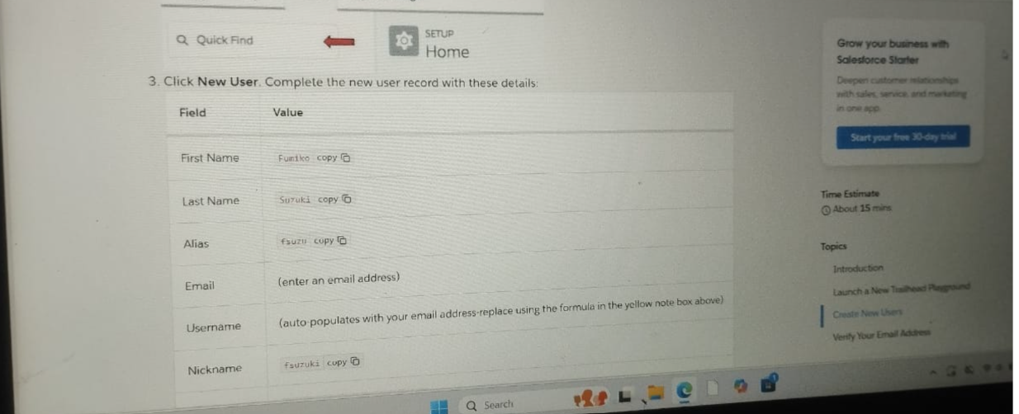
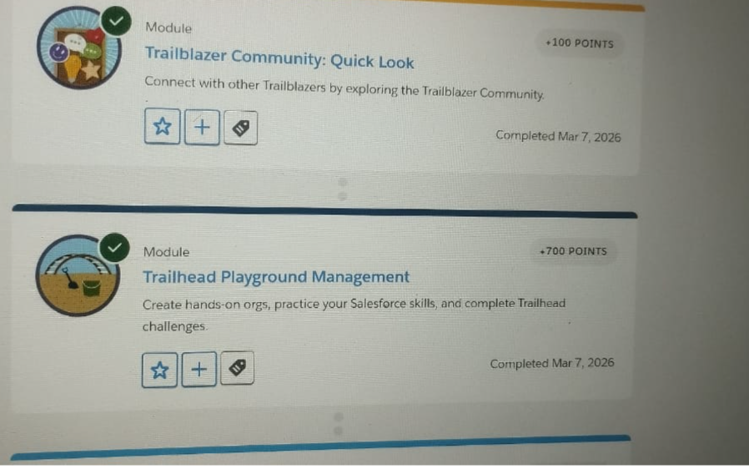
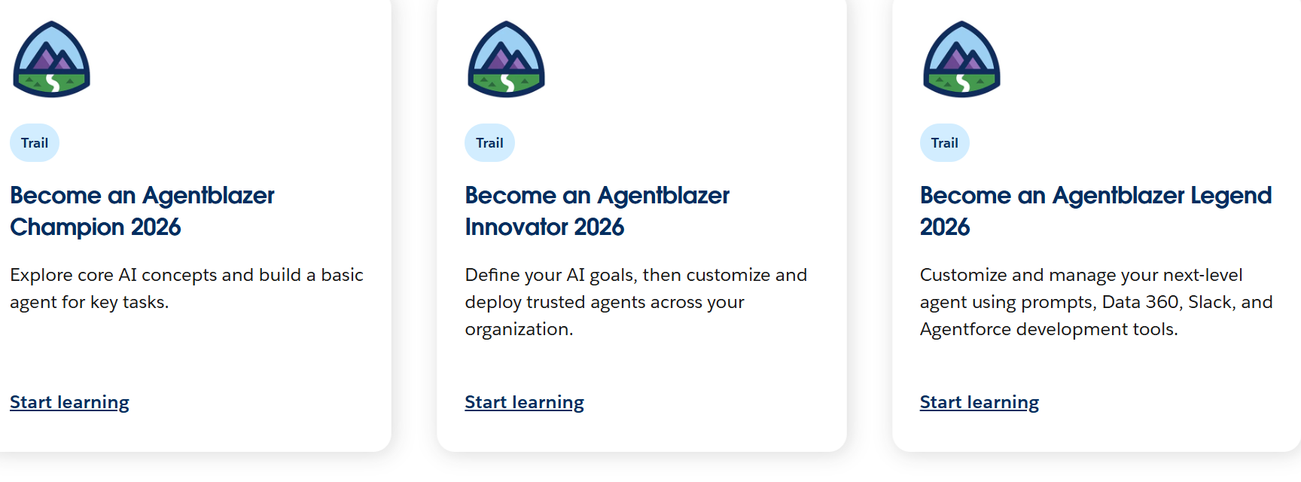
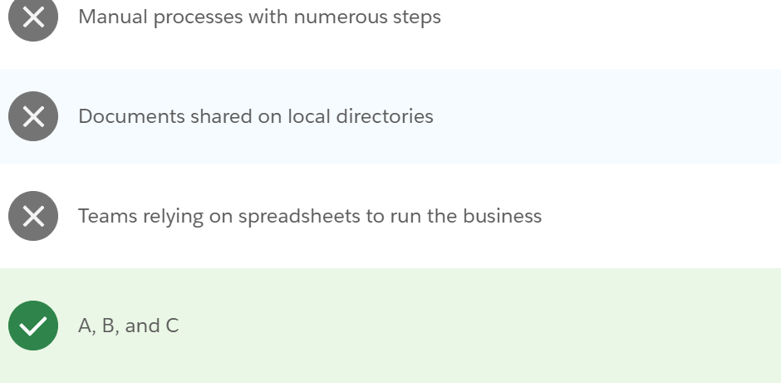
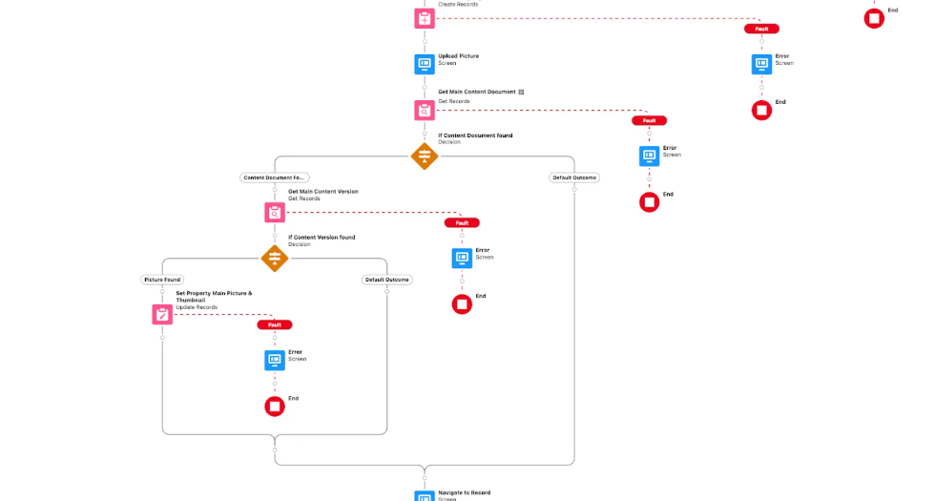

By:
Dhamodhiran .V
Kumar.V
Sachin.S
Janani.A

THANK YOU

